ultramirinc.champs_mood.fragments

Class MyAdapterSearch

java.lang.Object android.support.v7.widget.RecyclerView.Adapter<MyViewHolderSearch>

ultramirinc.champs_mood.fragments.MyAdapterSearch



public class MyAdapterSearch

extends android.support.v7.widget.RecyclerView.Adapter<MyViewHolderSearch>

Created by William on 2017­04­06. This class creates a binding between the raw data and the visual interpretation for the results . This class binds it with a MyViewHolderNotification object.

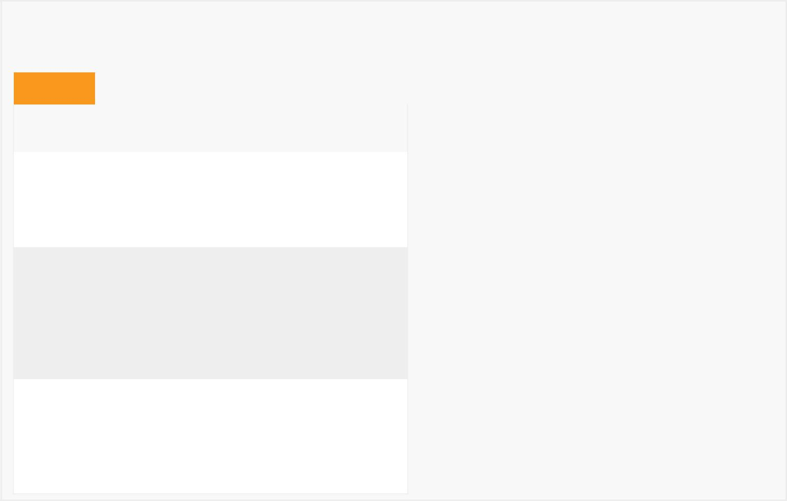

*Field Summary*

Fields

|  |  |
| --- | --- |
| Modifier and Type | Field and |
|  | Description |

private android.content.Context context

The context to the activity

private boolean isPokable

Determines if the friend can be poked or not

private java.util.List<User> list

Contains the list of the user's search

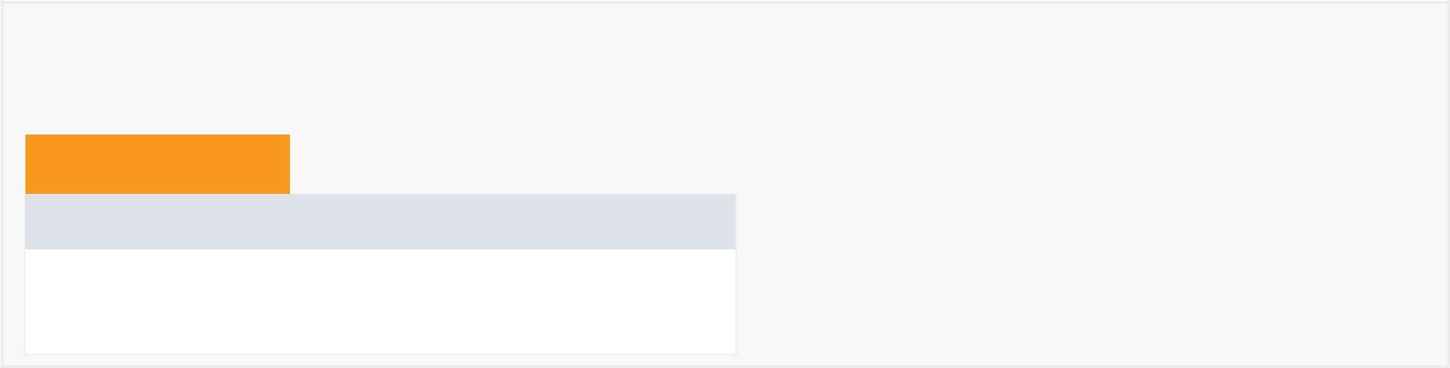

*Constructor Summary*

Constructors

Constructor and Description

MyAdapterSearch(java.util.List<User> list, android.content.Context context)



*Method Summary*

|  |  |  |  |  |  |  |  |  |  |  |
| --- | --- | --- | --- | --- | --- | --- | --- | --- | --- | --- |
| All Methods |  |  | [Static Methods](javascript:show(1);) | |  |  | [Instance Methods](javascript:show(2);) |  | [Concrete Methods](javascript:show(8);) |  |
| Modifier and Type | | |  | Method and Description | | | | |  |  |
| private int | | |  | adaptDayOfWeek(int weekday) | | | | |  |  |
|  |  |  |  | There's a mismatch between our original int values of weekdays with the | | | | | | |
|  |  |  |  | java.utils.calendar integer values of weekdays. | | | | | | |
|  |  |  | |  |  |  | |  |  |  |
| java.lang.String | | | | breakCalculator(User u, | | | | |  |  |
|  |  |  |  | java.util.ArrayList<Break> friendBreaks) | | | | | | |
| private void | | |  | checkBreakStatus(MyViewHolderSearch viewHolderSearch,User u) | | | | | | |
|  |  |  |  | Gets the user's break status (time before a break, in break or no more | | | | | | |
|  |  |  |  | breaks). | | |  |  |  |  |
|  |  |  |  |  |  |  | |  | |  |
| static long | | |  | getDateDiff(java.util.GregorianCalendar date1, | | | | | | |
|  |  |  |  | java.util.GregorianCalendar date2, | | | | |  |  |
|  |  |  |  | java.util.concurrent.TimeUnit timeUnit) | | | | | | |
|  |  |  |  | Returns the difference between two dates in milliseconds. | | | | | | |
| int | | |  | getItemCount() | | |  |  |  |  |
|  |  |  |  | Returns the size of the list. | | | | |  |  |
| void | | |  | onBindViewHolder(MyViewHolderSearch myViewHolderSearch, | | | | | | |
|  |  |  |  | int position) | | |  |  |  |  |

Binds the information from a given search with the ViewHolder.

MyViewHolderSearch onCreateViewHolder(android.view.ViewGroup viewGroup, int itemType)

Creates a Visual interpretation using a custom ViewHolder.

private void poke(User user)

Pokes a given user.

Methods inherited from class android.support.v7.widget.RecyclerView.Adapter

bindViewHolder, createViewHolder, getItemId, getItemViewType, hasObservers, hasStableIds, notifyDataSetChanged, notifyItemChanged, notifyItemChanged, notifyItemInserted, notifyItemMoved, notifyItemRangeChanged, notifyItemRangeChanged, notifyItemRangeInserted, notifyItemRangeRemoved, notifyItemRemoved, onAttachedToRecyclerView, onBindViewHolder, onDetachedFromRecyclerView, onFailedToRecycleView, onViewAttachedToWindow, onViewDetachedFromWindow, onViewRecycled, registerAdapterDataObserver, setHasStableIds, unregisterAdapterDataObserver

Methods inherited from class java.lang.Object

clone, equals, finalize, getClass, hashCode, notify, notifyAll, toString, wait, wait, wait



*Field Detail*

context

private android.content.Context context

The context to the activity

list

private java.util.List<User> list

Contains the list of the user's search

isPokable

private boolean isPokable

Determines if the friend can be poked or not

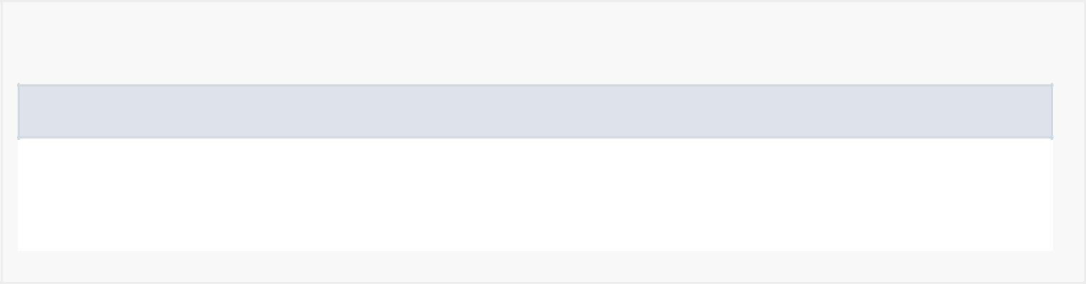

*Constructor Detail*

MyAdapterSearch

public MyAdapterSearch(java.util.List<User> list, android.content.Context context)

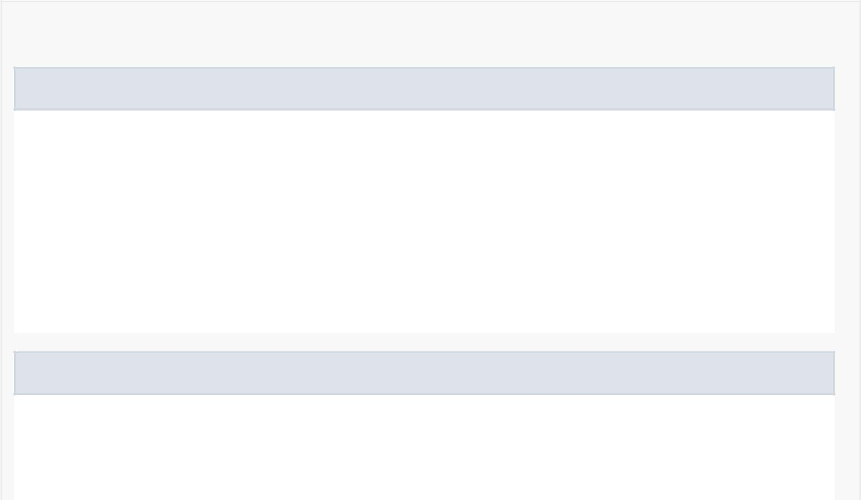

*Method Detail*

onCreateViewHolder

public MyViewHolderSearch onCreateViewHolder(android.view.ViewGroup viewGroup, int itemType)

Creates a Visual interpretation using a custom ViewHolder.

Specified by:

onCreateViewHolder in

class android.support.v7.widget.RecyclerView.Adapter<MyViewHolderSearch>

onBindViewHolder

public void onBindViewHolder(MyViewHolderSearch myViewHolderSearch, int position)

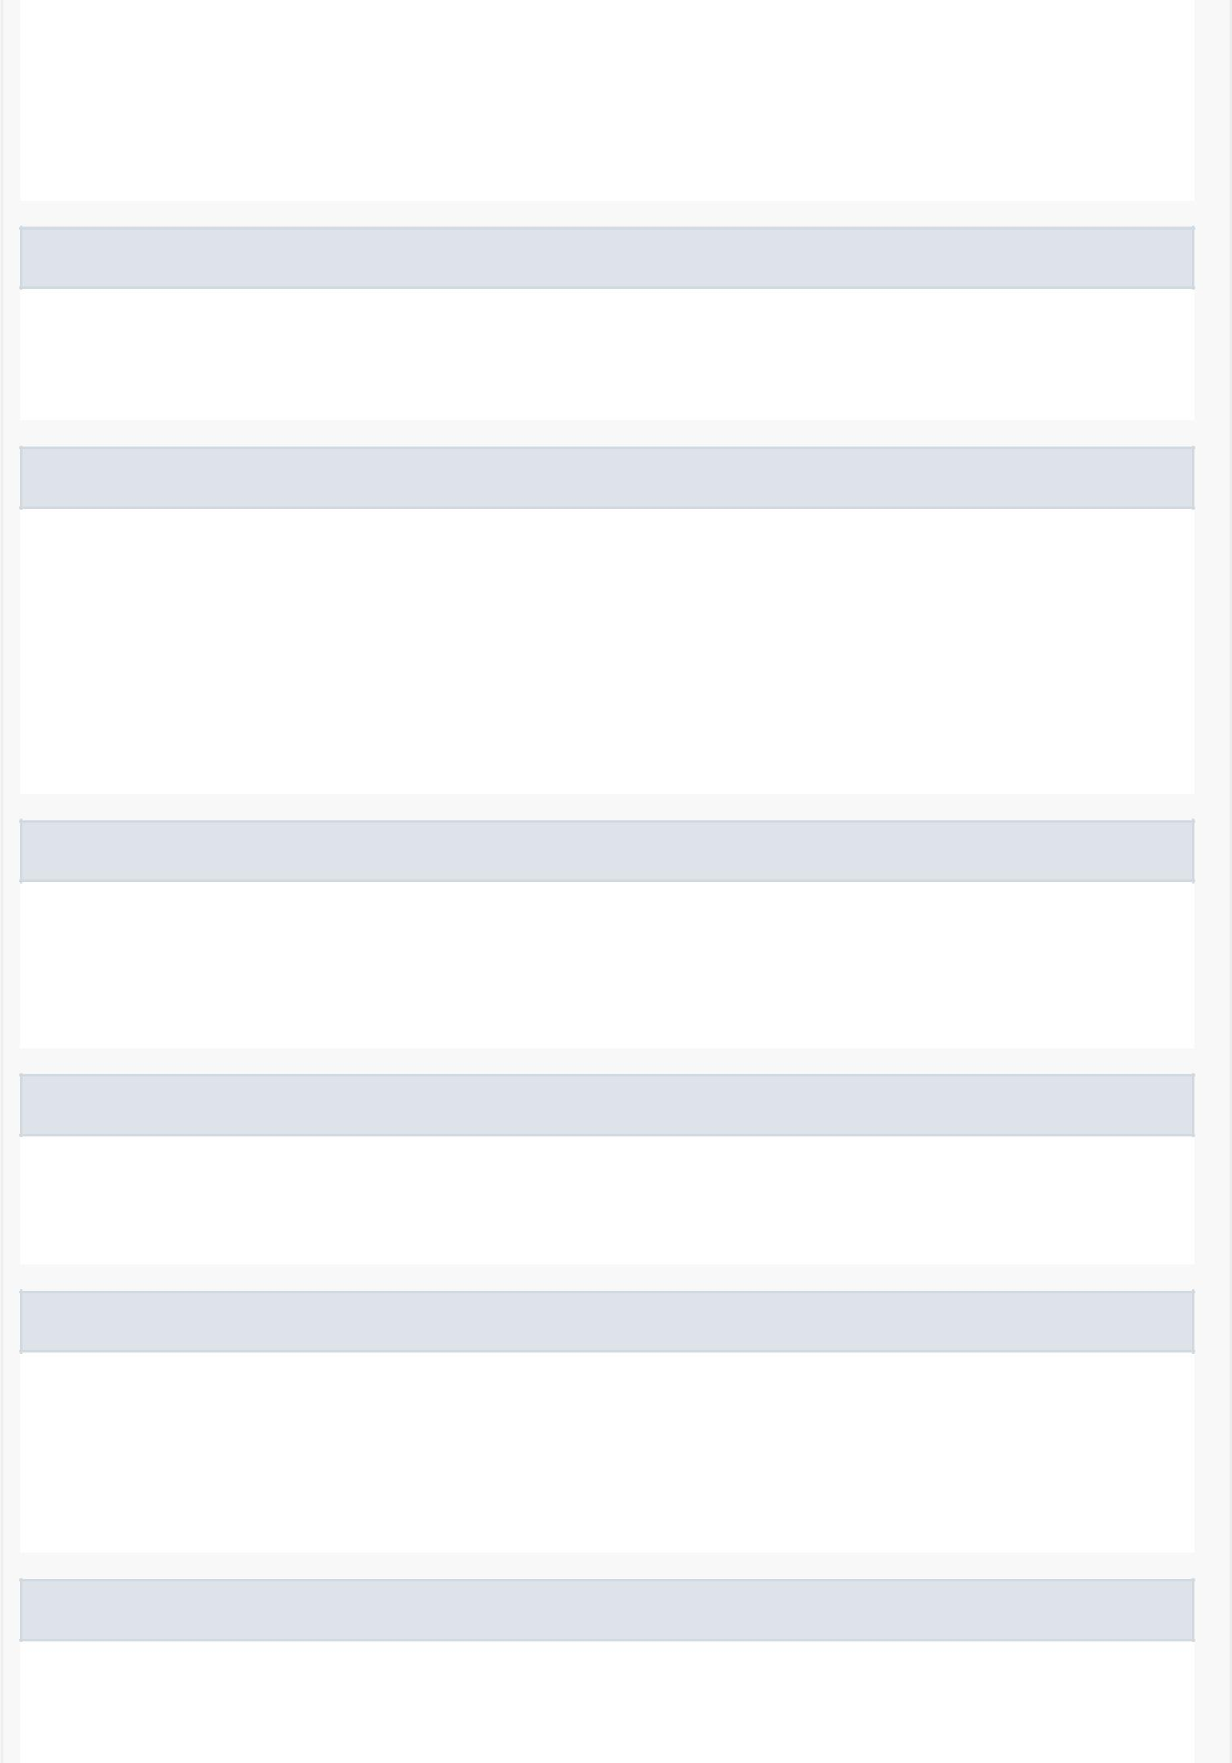Binds the information from a given search with the ViewHolder.

Specified by:

onBindViewHolder in

class android.support.v7.widget.RecyclerView.Adapter<MyViewHolderSearch>

poke

private void poke(User user)

Pokes a given user.

getItemCount

public int getItemCount()

Returns the size of the list.

Specified by:

getItemCount in

class android.support.v7.widget.RecyclerView.Adapter<MyViewHolderSearch>

checkBreakStatus

private void checkBreakStatus(MyViewHolderSearch viewHolderSearch, User u)

Gets the user's break status (time before a break, in break or no more breaks).

breakCalculator

public java.lang.String breakCalculator(User u,

java.util.ArrayList<Break> friendBreaks)

getDateDiff

public static long getDateDiff(java.util.GregorianCalendar date1, java.util.GregorianCalendar date2, java.util.concurrent.TimeUnit timeUnit)

Returns the difference between two dates in milliseconds.

adaptDayOfWeek

private int adaptDayOfWeek(int weekday)

There's a mismatch between our original int values of weekdays with the java.utils.calendar integer values of weekdays.